PERSONS WITH DISABILITIES

MISUSE OF PARKING COMPLAINT REPORT

Under Act 1003 of 2017, the Arkansas General Assembly established a mechanism for a person to report the suspected misuse of a disabled license plate, disabled placard, or a disabled parking space to the Office of Motor Vehicle of the Arkansas Department of Finance and Administration.

Complaint must be based on fact rather than suspicion. Please remember not all disabilities are apparent nor does every individual with a disability use a mobility device such as a cane, walker, scooter or wheelchair. Never confront any person you think may be abusing the program. If the situation requires immediate attention, please contact your local police department.
1-866-NOPARK5
Please Check Applicable Box:
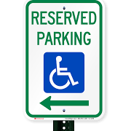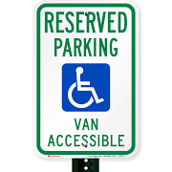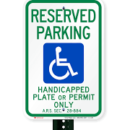

All recorded incident data is collected to further the cause in advocating Arkansas Laws, educating those with parking privileges and those that continue to violate the rights of Arkansans with disabilities.

Parked in Accessible Parking Space
without a plate or placard

Parked in Van Accessible Space
without a plate or placard

Parked in striped access aisle area
Parkeed

Placard Number  (if known) | Vehicle Make | Vehicle Model | License Plate Number

Date, Time and Location of the Misuse/Abuse:
(Address or Business, City and County)

Briefly describe the Misuse/Abuse:

To submit by phone call 1-866-NOPARK5

Submit by Mail Submit In Person
Department of Finance and Administration Ledbetter Building
P.O. Box 1272 Room 2440
Room 2440 1900 West 7th Street
Little Rock, AR 72203 Little Rock, Arkansas 72201

By signing my name, I hereby state that the information provided herein is true and correct to the best of my knowledge.

Name Date Phone (optional)

THANK YOU FOR REPORTING!

